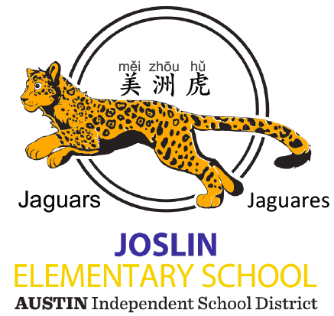
Joslin Elementary School PTA
4500 Menchaca Road
Austin, TX 78745
www.joslinpta.com

Joslin Elementary School is a small, Title I school located in the heart of South Austin, on the corner of Menchaca Road and Redd Street. Joslin is a true hidden gem offering opportunities for children to learn in English, Spanish,and Mandarin, experience a wide variety of after school enrichment, and thrive in a loving and supportive academic community.

Dear Friends in the Local Business Community,

We hope this letter finds you well. The Joslin Elementary School PTA is seeking your business sponsorship and tax-deductible donation to fundraise for our school! In exchange for your generous donation, we would be proud to display your name prominently on our NEW fence along Menchaca Road. The intersection of Redd and Menchaca sees thousands of South Austin commuters daily as Menchaca Road is a prominent gateway to Highway 290, South Lamar, South Congress, Zilker Park, and Downtown. This prime location ensures high visibility, providing a fantastic platform for your business to reach the wider South Austin community and showcase your support for education. By participating in this program, you not only gain exposure but also contribute directly to the betterment of Joslin Elementary School.

Joslin PTA and Joslin Elementary School

Joslin’s PTA is deeply committed to improving our school grounds, community, educational opportunities and teacher and staff support. In 2023, our organization was awarded the coveted AISD PTA of the Year award! We are truly making our school a better place to learn and grow. Joslin is a Title I school with a high population of low income and some homeless families. Our PTA is dedicated to supporting these children and offering them the same opportunities as their peers. Each year, we fund and coordinate a creative writing program for our third graders, a garden education program for our younger grades, a halloween carnival, school dance, movie and board game nights, as well as cultural appreciation events that honor our diverse community.

We support Joslin classrooms by awarding “mini-grants” for field trips, classroom supplies, and supplemental materials. We also host many teacher and staff appreciation events throughout the year. With your generous donation, we hope to expand both our mini-grant program and the ways we show love for our teachers and staff. Our PTA has committed to funding a campus-wide Leadership program “Leader-in-Me” over the next 3 years. Your donation will make that possible!

Lastly, our PTA is committed to creating beautiful, sustainable, and inspiring outdoor spaces for our students to learn and play. Over the past year, we have transformed our Pre-K courtyard and have plans to create a beautiful outdoor classroom and butterfly garden. In the coming year, we are hoping to refinish our outside basketball court to address safety and durability for our kids. With your sponsorship, we can make that possible!

Sponsorship Options

Please select your Sponsorship Level.

- Jaguar Champion ($2100): 48”x 36” sign with your custom ad (custom ad is subject to approval by PTA and school administrators for content and school appropriateness) hung on the Menchaca Road fence (includes the price of the sign)
- Jaguar Friend ($1100): 48”x 36” sign with your name or logo hung on the Menchaca Road fence (includes the price of the sign)
- Jaguar Fan ($700): 48”x 36” sign with your name or logo hung on the south parking lot fence along Cimarron Road (includes the price of the sign)
- Halloween Carnival Sponsor ($150): sponsor a booth at our annual “Spooktacular” Halloween Carnival. Your business name will be displayed (8”x12” sign) at the carnival and on our website (www.joslinpta.com), November 2025 newsletter, and on our Sponsorship poster at the event.

How to Reserve Your Spot

To secure your advertising space on the Joslin Elementary School fence, please complete the attached reservation form and complete payment by check or Venmo (@Joslin-PTA). Spaces are limited, so don't miss out on this fantastic opportunity! Your sign will be displayed for 1 calendar year from the date the sign is hung. Please have the artwork and logo ready to print. Please be aware that Joslin is located in a very high traffic area and although your sign will be tightly zip tied to the fence, there is a small possibility your sign might go missing. Joslin PTA will purchase the initial sign and if a new one is ever required, we will ask you to replace it at the cost of $8 per square foot through our printer (price subject to change).

Thank you for considering this unique opportunity. PTA is a registered 501(c)3 non-profit and your donation is tax deductible. Please refer to EIN# 74-6085697. We look forward to partnering with you to create a positive impact on our community and support the education of our children. Please email joslinpta@gmail.com with questions and reservations requests!

Best Regards,
Sabrina Joy Dot Aikman
PTA President Vice President and Fundraising Chair
Joslin Elementary School PTA Joslin Elementary School PTA

Joslin PTA Sponsorship Reservation Form

Business Name

Business Address

Contact Name

Contact Title

Contact Phone Number

Email Address

Sponsorship Level

Date of Sponsorship Payment

Additional Comments:

